Case 8-US-AK-Eskimo-Ivory Cutter
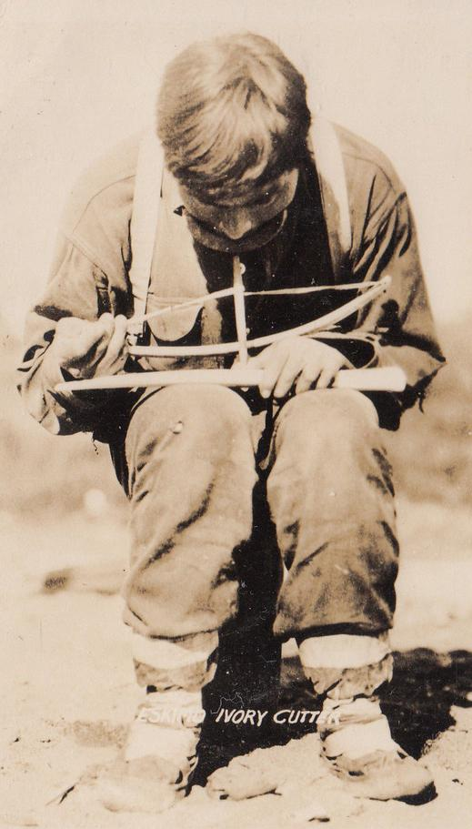
Postcard
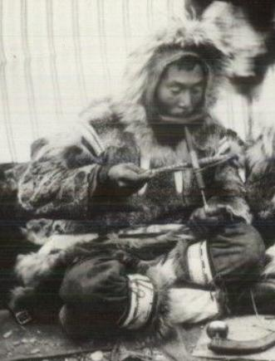
postcard 1930’s-1940’s
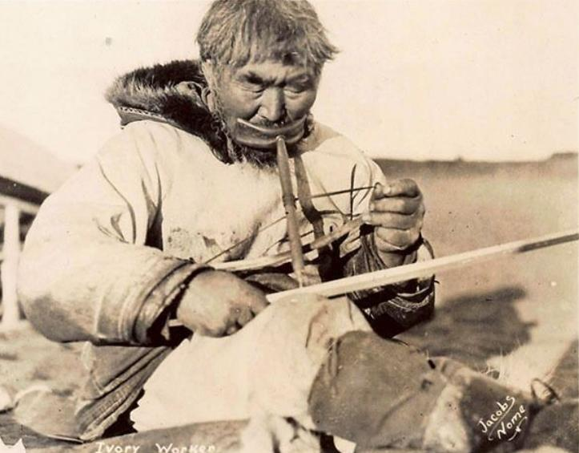

Nome AK Native Working w/ Ivory, Signed Jacobs, 1947
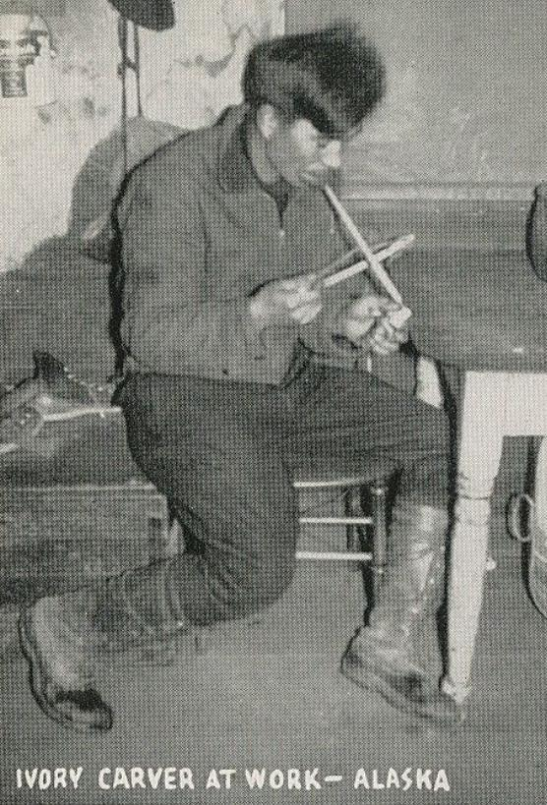
Northwest postcard Distributors

